Angle Between Two Lines
# Source: AI Source: Provided by: [Data Path: Persons Table -> ID Column: 1, Name_En Column: Motasem Essam] -> From: [ChatGPT] on [7/25/2026]
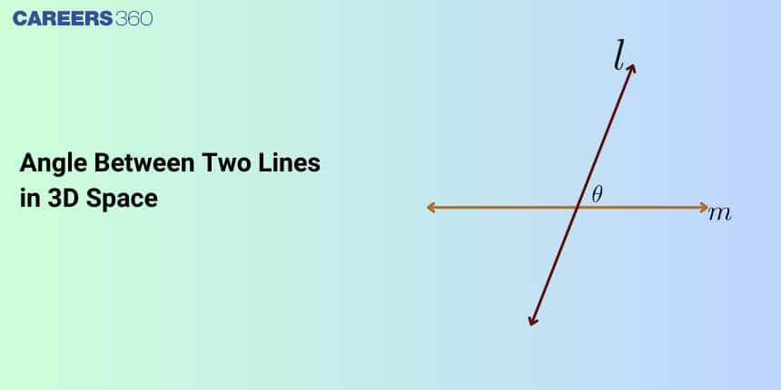
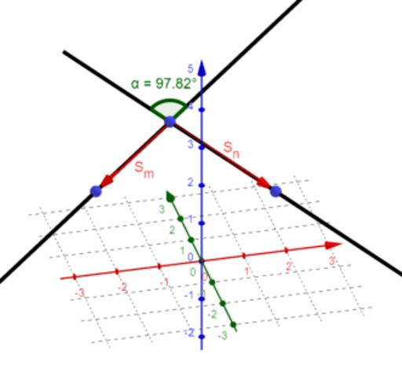
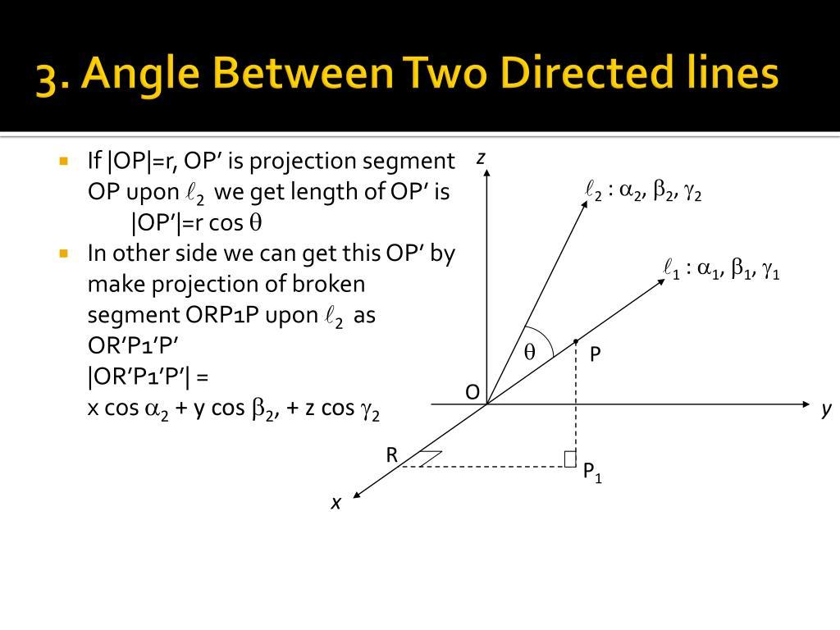

Definition
# Source: AI Source: Provided by: [Data Path: Persons Table -> ID Column: 1, Name_En Column: Motasem Essam] -> From: [ChatGPT] on [7/25/2026]
The angle between two lines in solid geometry is the smallest angle formed by their directions when the lines are compared in three-dimensional space.
The two lines may intersect, be parallel, or be skew (non-coplanar). Even when two lines do not physically intersect, the angle between their directions can still be defined using parallel translations of the lines or their direction vectors.
For two intersecting lines, the angle is measured at their intersection. For skew lines, imagine moving one line parallel to itself until it passes through a point on the other line; the angle between their directions is then measured.

Simple Definition
# Source: AI Source: Provided by: [Data Path: Persons Table -> ID Column: 1, Name_En Column: Motasem Essam] -> From: [ChatGPT] on [7/25/2026]
The angle between two lines tells us how much the directions of the lines differ.
- If the lines point in the same or opposite directions, the angle between them is $0^{∘}$ or ${180}^{∘}$ as directed angles, but the usual undirected angle between lines is $0^{∘}$.
- If they meet at a right angle, the angle between them is ${90}^{∘}$.
- If their directions are neither parallel nor perpendicular, the angle is generally between $0^{∘}$ and ${90}^{∘}$ when using the standard smaller-angle convention.

Key Characteristics
# Source: AI Source: Provided by: [Data Path: Persons Table -> ID Column: 1, Name_En Column: Motasem Essam] -> From: [ChatGPT] on [7/25/2026]
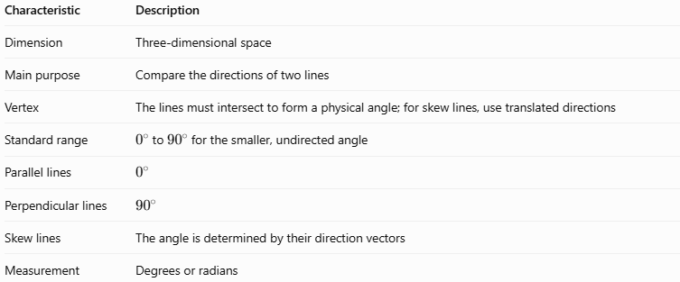
Characteristic | Description
Dimension | Three-dimensional space
Main purpose | Compare the directions of two lines
Vertex | The lines must intersect to form a physical angle; for skew lines, use translated directions
Standard range | $0^{∘}$ to ${90}^{∘}$ for the smaller, undirected angle
Parallel lines | $$0^{∘}$$
Perpendicular lines | $${90}^{∘}$$
Skew lines | The angle is determined by their direction vectors
Measurement | Degrees or radians

Geometric Representation
# Source: AI Source: Provided by: [Data Path: Persons Table -> ID Column: 1, Name_En Column: Motasem Essam] -> From: [ChatGPT] on [7/25/2026]
Imagine two lines, $l$ and $m$, with direction vectors $u$ and $v$. Their angle is represented by $θ$.
Illustration of two line directions and the angle between them. The smaller angle is used.
The drawing is a two-dimensional representation of the angle concept. In solid geometry, the same idea applies to directions in three-dimensional space.

Mathematical Representation and Formulas

A. Using direction vectors
# Source: AI Source: Provided by: [Data Path: Persons Table -> ID Column: 1, Name_En Column: Motasem Essam] -> From: [ChatGPT] on [7/25/2026]
Let the direction vectors of the two lines be
$$u=\left(u_{1},u_{2},u_{3}\right)$$
and
$$v=\left(v_{1},v_{2},v_{3}\right).$$
The angle between their directions is found using the dot product:
$$\cos{θ}=\frac{\left|u⋅v\right|}{\left\|u\right\|\left\|v\right\|}$$
Therefore,
$$\boxed{θ=\cos^{-1}\left(\frac{\left|u⋅v\right|}{\left\|u\right\|\left\|v\right\|}\right)}$$
The absolute value makes $θ$ the smaller, undirected angle between the lines.
The dot product is
$$u⋅v=u_{1}v_{1}+u_{2}v_{2}+u_{3}v_{3.}$$
The magnitudes are
$$\left\|u\right\|=\sqrt{u_{1}^{2}+u_{2}^{2}+u_{3}^{2}}$$
and
$$\left\|v\right\|=\sqrt{v_{1}^{2}+v_{2}^{2}+v_{3}^{2}}.$$

B. Special cases
# Source: AI Source: Provided by: [Data Path: Persons Table -> ID Column: 1, Name_En Column: Motasem Essam] -> From: [ChatGPT] on [7/25/2026]
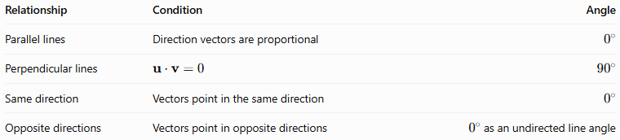
Relationship | Condition | Angle
Parallel lines | Direction vectors are proportional | $$0^{∘}$$
Perpendicular lines | $$u⋅v=0$$ | $${90}^{∘}$$
Same direction | Vectors point in the same direction | $$0^{∘}$$
Opposite directions | Vectors point in opposite directions | $0^{∘}$ as an undirected line angle

Worked Examples
# Source: AI Source: Provided by: [Data Path: Persons Table -> ID Column: 1, Name_En Column: Motasem Essam] -> From: [ChatGPT] on [7/25/2026]
Example 1: Two perpendicular lines
Suppose the direction vectors are
$$u=\left(1,0,0\right), v=\left(0,1,0\right).$$
Calculate their dot product:
$$u⋅v=\left(1\right)\left(0\right)+\left(0\right)\left(1\right)+\left(0\right)\left(0\right)=0.$$
Since the dot product is zero, the vectors are perpendicular.
Answer: $\boxed{θ={90}^{∘}}$
Example 2: Finding an angle using direction vectors
Let
$$u=\left(1,0,0\right), v=\left(1,1,0\right).$$
First, calculate the dot product:
$$u⋅v=1.$$
Next, calculate the magnitudes:
$$\left\|u\right\|=1, \left\|v\right\|=\sqrt{2}.$$
Substitute into the formula:
$$\cos{θ}=\frac{1}{\sqrt{2}}.$$
Therefore,
$$θ=\cos^{-1}\left(\frac{1}{\sqrt{2}}\right).$$
Answer: $\boxed{θ={45}^{∘}}$
Example 3: Two parallel lines
Suppose the direction vectors are
$$u=\left(2,4,6\right), v=\left(1,2,3\right).$$
Notice that
$$u=2v.$$
The direction vectors are proportional, so the lines are parallel.
Answer: $\boxed{θ=0^{∘}}$
Example 4: Angle between two skew lines
Consider two lines with direction vectors
$$u=\left(1,0,0\right), v=\left(0,1,1\right).$$
The lines themselves could occupy different positions in space and never intersect. However, their direction vectors still determine their angle.
Calculate the dot product:
$$u⋅v=0.$$
Thus, their directions are perpendicular.
Answer: $\boxed{θ={90}^{∘}}$
This illustrates an important distinction: two skew lines can have perpendicular directions even though the lines do not physically intersect.

Comparison With Related Concepts
# Source: AI Source: Provided by: [Data Path: Persons Table -> ID Column: 1, Name_En Column: Motasem Essam] -> From: [ChatGPT] on [7/25/2026]
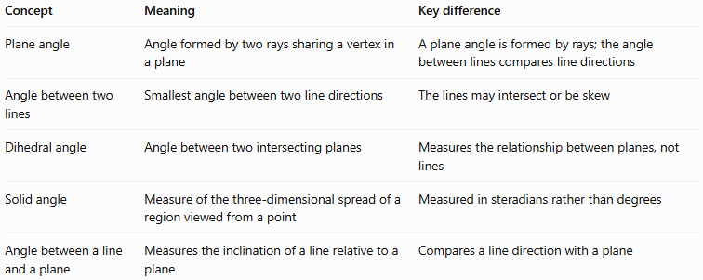
Concept | Meaning | Key difference
Plane angle | Angle formed by two rays sharing a vertex in a plane | A plane angle is formed by rays; the angle between lines compares line directions
Angle between two lines | Smallest angle between two line directions | The lines may intersect or be skew
Dihedral angle | Angle between two intersecting planes | Measures the relationship between planes, not lines
Solid angle | Measure of the three-dimensional spread of a region viewed from a point | Measured in steradians rather than degrees
Angle between a line and a plane | Measures the inclination of a line relative to a plane | Compares a line direction with a plane

Applications
# Source: AI Source: Provided by: [Data Path: Persons Table -> ID Column: 1, Name_En Column: Motasem Essam] -> From: [ChatGPT] on [7/25/2026]
Angles between lines in solid geometry are useful in:
- Architecture: determining the orientation of structural beams.
- Engineering: checking whether shafts, rods, and supports are aligned or perpendicular.
- Computer graphics: calculating object orientations in three-dimensional scenes.
- Navigation and robotics: comparing movement directions in three-dimensional space.
- Descriptive geometry: analyzing the relationships between edges, diagonals, and axes of solids.

Key Points
# Source: AI Source: Provided by: [Data Path: Persons Table -> ID Column: 1, Name_En Column: Motasem Essam] -> From: [ChatGPT] on [7/25/2026]
- The angle between two lines measures the difference between their directions.
- The standard angle between two undirected lines is the smaller angle, from $0^{∘}$ to ${90}^{∘}$.
- Intersecting lines form an angle at their intersection.
- Skew lines do not intersect, but their directions still define an angle.
- Parallel lines have an angle of $0^{∘}$.
- Perpendicular directions have an angle of ${90}^{∘}$.
- The dot-product formula can calculate the angle in three-dimensional space.

Conclusion
# Source: AI Source: Provided by: [Data Path: Persons Table -> ID Column: 1, Name_En Column: Motasem Essam] -> From: [ChatGPT] on [7/25/2026]
The angle between two lines in solid geometry describes how their directions relate in three-dimensional space. It applies to intersecting, parallel, and skew lines, and it can be calculated using direction vectors and the dot-product formula. Understanding this angle helps distinguish parallel and perpendicular directions and analyze the geometry of three-dimensional objects.

